Craigslist responses

First email: 4/4
This would help a lot I’m not working now and take care of mom. Just let me know what I need to do thank you
Last email: 4/4
Thank you so much for helping people in need during these hard times my family appreciates it and so will others. Thank you
-Danny

First email: 4/4
Hi I don’t know If this is real or not But I’m praying that it is I am a mom of four we have no money for food right now and are struggling really bad Due to me and my husband not having a job right now I would greatly appreciate if we could get some of your help

Last email: 4/4
Thank you, guys, so very much. This was truly a blessing. My kids are so happy, and I can get a break from crying, and worrying about being able to feed them for a little. Please don’t ever stop being the kind and caring people that you are the world definitely needs more people like you all!
-Jasel

First email: 4/4
Hi, I noticed your Ad on Craigslist for the Free Food
We could surely use some right now. Please let me know if this is possible!
Thank-you,
Stay Safe & God Bless 😊

Last email: 4/5
🤗 Guys,
I wanted to give both of you a HUGE shout out of appreciation! I never thought that I'd see something like the coronavirus in my lifetime. Even though this situation is So depressing and devastating to so many, it really does bring out the Best in People Also, and what you guys did for us and others is just so generous, compassionate, and unselfish. You’re in my prayers, and I truly believe in karma and as far as I'm concerned you guys deserve all the best!
Take Care of Yourselves,
STAY SAFE & God Bless 😊
-Lisa

First email: 4/4
I am interested in the free food if still available.
Thank you.

Last email: 4/4
THANK YOU FROM THE BOTTOM OF MY HEART FOR ALL OF THE FOOD! MY KIDS ARE THRILLED AND CAN’T WAIT TO TRY SOME OF THE SNACK ITEMS OUT!!
YOURE AN ANGEL!!
THANKS AGAIN!!
-Dawn

First email: 4/4
Hi,
Single dad of three; please help. Thanks

Last email: 4/5
Great thanks

First email: 4/5
I was emailing about the food help. At for children in my home plus myself I could really use the help.
Jessica
Last email: 4/5
I just wanted to reach out and express my gratitude for what your business is selflessly doing for the community. I cannot thank you enough for the food distribution you welcomed my family to come receive. Being a single mother of 4 underage children is hard at times as it is but during the crisis, we are enduring is making it much more difficult financially and the help you offered us was a blessing!!!
Bless you for you kindhearted generosity!!!!
Jessica

First email: 4/5
Good morning. If these are still available. I will take as many up to 4 as you can spare. 1 will be for my wife and I the others will be distributed to my 4 children living out on their own. Each of which has had their livelihood disrupted in these crazy times

Last email: 4/5
Thank you very much. I was the 1st one there. We know a family that will use the infant products. I am using some for my wife and I (Tuna) and what we don’t keep will be divided between my 4 sons’ households. I can’t thank you enough for your generosity. It will all be put to good use.
Thank you again
Michael

First email: 4/5
Good evening is this still available?
We are a house of 7 and anything helps tremendously. Not to mention you guys are helping so many

Last email: 4/5
Hello again, I wanted to say thank you again. What you guys are doing is truly a blessing to families especially a family like mine. Times are trying at this time and to know there is still some great people helping out is amazing. Thank you again mom of 7.
-Tarah

First email: 4/5
Hi, thank you for helping in food. It's a hard time for a family with kids and cannot work now. May I go to pick up some food? When? thank you. Please reply ASAP. Angle

Last email: 4/5
Thank you so much for your good heart help in giving free food to people in need. You and your partners are good heart people. - God bless you tow!
Angle

First email: 4/5
Good morning. We are in dire need of any type assistants. We are a family of five. We have a 12yr old girl and 4yrs old twins boy & girl. Twins have sensory processing disorder & add which is very hard to take them anywhere. It's been a long rough year & a half. Hit rock bottom was litterly homeless for 10 months. Been rough. Thank you for helping people in need. Even if I'm too late we need more people like you on this earth. Thank you.

Last email: 4/5
Yes I will be there! Thank you so much for reaching out & remembering me. Greatly appreciated! I will hopefully be driving wife's car a blue Ford fusion. It's going to take me forever to recover from this pandemic if I'm even able to you know. Just started my car hauling business not even a year ago I'm the little guy trying to compete with the big guys who can do six eight cars at a time I can only do two. We'll see.. I will see you tmrrw around noonish!

First email: 4/6
Good Morning, bless your heart do you have any food left?

Last email: 4/6
I do believe that theirs’s Angel's among us like you guys , I greatly appreciate you for helping me and my kids in this time of need , like I told you before I lost my job and its quite difficult for our every day , if you have anything extra or left over I would greatly appreciate the help,
Thank you once again, GOD BLESS!
-Aniyah

First email: 4/6
Hi, my name is Jennifer. I am in need of food. If there is food still available, I would greatly appreciate it. I can be to the address posted in 30-45 mins. Please let me know.
Thank you

Last email: 4/6
It was nice to meet you also. The food is very much appreciated. Such a kind thing for you guys to do during this hard time. Thank you again.
Jennifer

First email: 4/6
I would like to be considered for the free food! I’m single mom and laid off so source of income or help right now
Anna

Last email: 4/6
I would like to thank you for providing us with food! I am very grateful, and it is one less thing I have to worry about right now! You are a true blessing and I hope amazing things happen in your life’s.
Anna

First email: 4/7
hello, I saw ad on craigslist is there still food available for families in need?

Last email: 4/7
Hi, sorry not sure I got you or your partners name. I just wanted to say Thank you so much. The Food I received from you is greatly appreciated. Me and my family are so very thankful. My husband say's thank you for the beer as well. I will be praying for you all at VIMA during this time, the world needs more people like you two willing to come together in times of need. Again, thank you 🙏🏼💜
-Stacy

First email: 4/8
Hi, we could use the food please. With no work and 2 teens food is scarce.
Thank you
Barbara

Last email: 4/8
Hi Michael & Michael,
Thank you so much for the food and detergent assistance!! It really helps!!! With hours cut and my husband not working since this happened it has been tough. I'm glad to spend the extra time with our kids. I know we will all get through this ❤ because of people like you both. When kids say they are still hungry after a meal worries me not just for my kids but for all kids in the 🌎. We finally got our community garden leveled and ready. We are hoping we can get enough produce to help the neighborhood! Definitely going to pay it forward in your honor. Thank you again and I hope your families are healthy, safe and well!!!
Barbara

First email: 4/7
Hi there,

First, I would like to thank you for your kind heart in this time of crisis. I was recently laid off from my job as a server at a restaurant in Royal Oak due to all of the closures.

Do you still have any bags available? If so, I can happily meet you at your convenience.

Thank you and stay healthy ad safe.

Warm regards,
Claire

Last email: 4/7
Hi Mike,

Thank you again for meeting me today. On behalf of my little household, we would like to extend our sincere gratitude for your generosity.

I hope you and your family stay healthy and well during this time.

Warm regards,
Claire

First email: 4/8
Is this still available?

Last email: 4/8
Thank you so much! I am so excited to hide their baskets tonight for them to find in the morning. You have made our Easter, and I can't tell how much this means to me. The kids keep asking when this virus will be over. Nothing is the same for them. They miss school, friends, and family and going out.

But thanks to you Easter is here, and that is so good for them.
Thank you again!!!
Lorra, Paul, Meckinze and David

First email: 4/10
Is this still available? Family of 9

Last email: 4/10
My family and I thank you for the care package, Easter baskets and adult surprise we received yesterday. The community needs more people like you, grateful to have you in mine. Happy Good Friday and Easter to you and your family.
-Tanisha

First/last email: 4/10
﻿I am VERY INTERESTED!!!!
I just saw your post.
I was supposed to start a new job on March 3rd. Because of the pandemic I was told that they were not sure when and if I was going to be able to start. On February 28th I got unexpected immediate custody of my 2 year old and 10 month old great nieces from Cadillac, Michigan. Her parents have chosen drugs over her, so I feared her going to a foster home. That picture just scares the crap out of me, so I have custody of them.
My partner had identity theft on his social security number from 2017 so there’s no unemployment coming in when and if they straighten it out.
I have never been in a situation like this where I was the one that needed the help, I have always provided the help.
The little bit of money we had has went to diapers, baby formula and wipes. Therefore, making food for us not important since the 2 babies come first.
We would be greatly appreciative for 2 Easter baskets for the kids and any food for us you find in your heart to donate.
Thank you and god bless!

First/last email: 4/10
To whom it may concern my name is Shannon Nickson I live in Detroit Mich MY family and I have been affected by the corona virus severely I currently have two members who have been infected by the virus and ive lost three members of my extended family due to the virus I’m disabled and asthmatic so I’m unable to work and I’m caring for my elderly aunt who suffers with asthma as well as dementia so we are unable to drive or get out to get food and supplies and unfortunately we both are on fixed incomes due to disabilities I have a 16 old daughter who is home out of school so food is going even faster now that she can’t get free breakfast and lunch at school. I have to use my monthly check for rent lights gas and water and my cell phone bill so there is not much left after that I would greatly appreciate any help I’m god fearing and this would be a blessing from god for you to help my family and my
Self during this time I’m praying and just trusting God to heal this land and bless us to get through my friend seen your add and told me to contact you if you help me you would be god sent and I would forever be grateful if not god bless you still for blessing someone that is truly a blessing doing this time again thank you

First/last email: 4/10
Hello. I'm replying to this email to let you know of my situation. I unexpectedly lost my job at the end of last June without notice. I was told that my job had been eliminated.
I had just started a new job this March after three interviews with a home care agency. I worked my first three days on March 18, 19 & 20, 2020. These were also my last and only days worked since the last day in June 2019. The home care agency where I had just started has shut down due to the COVID19 crisis. I have four kids. Two of them have been staying with their dad for more than two weeks now so I know they will be able to eat without any worries. I'm not wanting Easter baskets for them, but a little extra food would definitely help so maybe they could come home again for a while. I live in Dearborn Heights. I'm hoping since the ad posted said about meeting, I'm hoping that we could meet somewhere near Dearborn Heights. I was thankful for my new job. I wanted to be able to improve things for us. But so many things cannot be fixed unless I can work and make money to fix them. My plans included being able to support my family and pay our bills as a single mom. My car needs an exhaust system so the car stops vibrating and shaking. The smell is the worst inside the car. I am still in need of getting a refrigerator. Ours stopped working and started blowing warm air the week before Thanksgiving. I have an old Pepsi cooler from a garage keeping things in my kitchen right now. Less than a week after the kids were out of school my microwave started sparking and had a fire ball the size of a large cantaloupe inside of it. So, we don't have a microwave. Next I need to replace my water heater that has been leaking on the basement floor for almost a year. And I also need to replace a leaking pipe with a bad valve over my boiler.
So... These are my unhappy truths. Please let me know if you are able to help out with what you were offering.
Thank you & Keep Safe
Mandy

First/last email: 4/10
I'm a single mother with 3 minors and one is special needs. I am a bartender and waitress who's been out of work since March 13th. Unemployment has continually kicked me off the site and all hope are getting bleak. I was living in a hotel room with my children until a week before the state shut down for restraunts and bars. I’m worried about feeding them and providing essential hygiene products. I need some help badly. Thank you.
Sincerely with hope:
-Kristen Richard

First email: 4/10
Hi my name is Adam I saw your post on Craigslist and think it's truly amazing what you all are doing to help families at home struggling right now I am a father of 4 and we also have custody of our nephew until he is of age so I know how hard times can be right now me and my wife have already gotten the feeling that Easter is almost hopeless and out of reach at this point given the nation wide crisis I'm a seasonal worker doing landscape but given the shut down I have been prevented from going back to work I am still receiving unemployment but it doesn't go far having everyone stuck in the house 24/7 anything you guys can do would be greatly appreciated

Last email: 4/17
Hello,
Yes that would be terrific thank you so much I will be their.

First email: 4/10
This pandemic has greatly impacted my family. Prior to this we had approved Fmla at my husband’s work. In march my husband was fired for too many points(only when this pandemic hit as all our days were originally approved fmla days) because his employer stated that he couldn’t prove he was with me at the drs or taking care of me ( which is what Fmla is for as the proof). We have filed a complaint with the federal department of wage adn labor division but they are shut down right now because of the pandemic. We are fighting to get unemployment because his employer fired him so technically we wouldnt be able to get unemployment. We are battling this and it’s in adjudication but it’s been since March 15th and nothing from them so far. They are waiting for his job to respond. We have no income as of right now. We have applied for state assistance but it’s been almost a month and still nothing. It’s been a horrible year. My husband’s last 2 pay checks had to get us a hot water heater because ours fell through the floor. WE have $6.28 to our name for the unforeseeable future. We have a van but could not afford the tags and insurance for it. We can’t even drive to food banks at this point. I can’t have him get arrested for driving without tags and insurance because he is my caregiver. IM also immunocompromised. As I had a spinal fusion in December as I recently lost my ability to walk last year in June, and have been sick 5 times since it, with the flu colds and etc. We could really use some help with food at this point.

Last email: 4/10
Yes I will be there

First/last email: 4/11
Hi, my family is in desperate need of food. With this epidemic going on its buts a much larger grocery bill for our home. And actually were in between homes right now also. Hopefully if things go how were planning them, we will be locking down our new place to stay by Monday. But for the since school started it's been even more difficult to do everything. With my mom being passed away and my daughters father gone now too. It makes a lot of our days just trying to keep things normal. Or as close to normal as we'd like to call our lives. We've been in and out of 4 different hotel/motels. All over most of Oakland county. Help with food now would be amazing. It would help us to save money while were moving into our place and
then when we get settled, I can pursue my food stamps. Thank you so much God Blesd

First email: 4/11
Interested in 3 Easter baskets 2 girls and 1 boy I'm a tile contractor and my wife a dog groomer almost out of savings with no work

Last email: 4/11
Thank you but my dad went and bought my kids some Easter stuff just now. You are a very special person for helping other's and I very much appreciate your kindness. I pray all this ends soon and we all can get back to life. Stay safe and healthy. Happy Easter from our family to yours
-Julie

First email: 4/11
Hello I am interested in the free food that you are kindly offering for those in need. I am currently laid off from a supplier plant in Warren, single mom with 2 young kids so my budget is extremely tight trying to pay rent, car insurance, utilities, incl necessities so this will help ease a little burden on my heavy load any help would be greatly appreciated thanks!

Last email: 4/12
Thank you so much!!!🙂🙂❤🤗

First email: 4/11
Good evening,

I would like to know how I can get information to receive Easter baskets for my 2 little ones. We recently moved out here right in the mist of the pandemic.

Then my wife started losing hours at work and I stopped traveling for my job and things got a bit rough all of a sudden. Thanks for your time reading a bit of our story. I appreciate your help in advance.
Jose

Last email:4/11
Awesome. Thanks again, and we will be there at 11 tomorrow.
Jose

First email: 4/11
I saw your message on Craigslist and my family has been directly affected by Covid 19. My husband is a full time DJ and with all events cancelled and bars closed he immediately lost all source of income. We have 3 children, a 13 year old son, a 12 year old son and a 8year old daughter. We would appreciate your support.
Thank you,
Reyonna

Last email: 4/11
Great! We can come at that time.

First email: 4/12
Good morning, Happy easter!! My name is Angela, I have 6 of my own children and I have had my best friends 2 kids staying with me since the stay at home order and shut down began. I have been laid off of work since march 13th and my best friend works for crittenton hospital. Well the kids have been here and driving me insane lol but I have yet to receive any unemployment benefits and my friend has been over worked but also we can't have her around any of the kids including hers. I found a sale at kroger yesterday and bought enough candy with the last $17 I had just so the kids could have something for today, which they understand whats going on and I believe they will know why they didn't get a whole bunch of stuff, but I definitely could use help with extra food. We dont have too much of anything for me to prepare for them to eat today and I would appreciate it if you could help us out in any way you are able to. Thank you for even taking the time to read my situation. May God bless you for your heart and even if you are unable to assist me. You truly are an Angel. People like you make my heart smile, please choose someone who needs it even if it’s not us...

Last email: 4/12
I can come anytime your available, I know its easter and I am assuming you also have a family. It would take me about 20 minutes to get to troy so let me know when you would like me to head your way. As soon as now is fine with me, thank you so much.

First email: 4/12
Thank you for your good heart help to the neighbors.
The COVID-19 has made my husband lost job and kids off school. as mother, I am struggling to get food. we appreciate your kind help.
May we go to get some food? thank you very much!
Amy

Last email: 4/17
Hi, Michael,
Thank you so much! I will go tomorrow. We appreciate your great kindness and help! God bless you!

First email: 4/12
Hello I saw your ad and believe my family will benefits from your kindness deed. My parent are layoff off from work and is helping me with my 3 kids. 9 months baby boy and two girls ages 11 and 9. I had to made to decision to keep working. So Im separated from my family because im still traveling in the world. I totally forgot about Easter. My mental trying to get to me. Im just trying to stay strong for my whole family. On top of that my baby sister has the Covid-19 virus and I also trying to be there for her. I Thank you in advance for thinking about other people I have 3 household that could benefits from this.
Thank you Monet

Last email: 4/14
Yes i can meet at 2pm Thank you

First email: 4/13
Hi, I am a mom of 3 and an Aunt of 134 nieces and nephews, (not kidding) in which I do my best to help feed (not all of them of course) and I also help a couple of young married couples w/ babies.who I love as my own. Im on a disability w/ many health issues, and lost husband 3 yrs ago. Many of them have lost thier jobs becsuse of the virus, and are barely getting by, I will go without to help them, but sometimes i need a little help to. If you would be willing to help me i will share with them. Thank you.

First email: 4/14
Hello, I'm Daryl and if this generous offer is still available, I would like to take you up on it. I'm located in Pontiac but I can meet closer to your location by public transportation. I'm 50+ yrs staying at home with my elderly mother (who suffers from dementia) & I can't work to pay for food right now for us, so if u can help, that would be greatly appreciated, thanks a lot

Last email: 4/15
Thank you for responding, yes I can meet you tomorrow morning on Lakeview Dr @ Golfview Dr, if that works for you (about 10 mins from you - it's as close as I can get to you by public transportation) I can be there by 10:45 am, my apologies but that is my only choice....hope to see you there, thanks again

Last email: 4/14
To all the kind people at Vima, I want to thank you very much for your food donation to me every little bit helps since I am on disability, and every little bit I get, I try to help someone else. Now I will be okay for a few days because of your help. I'd like to thank you very much for your kindness it gives me hope in humanity. You will be blessed thank you. And be safe.
Sincerely Tina

First/last email: 4/14
Hi, I just saw your posting. I wish I would have looked a few days ago. I wasn't able to afford any baskets this year for the 5 youngest. I'm wondering if you have any food left? I have a family of 9 and we are really having a very hard time. We did get to the point where we applied for food but were told it will be up to 30 days if we apply. My daughter is also looking for some help for her family of 3.

First email: 4/15
Hello... I was wondering if you still had food or and Easter baskets...My 4 small children were not able to celebrate Easter this year and we are in need of food... if you can help that would be greatly appreciated, We are really struggling with this pandemic and hope to be better off when this pandemic is over... Thank You !! I had seen your ad for food before but thought it was only for workers of covid 19 in need of food

Last email: 4/16
Hello....Yes I can be there today at 1:30 pm....Thank You!

First email: 4/16
Hi my name is Elisabeth the virus has made everyday Life hard. I'm already living in. Hotel Now I can't work not can my boyfriend I'm in beyond desperate need of help

Last email: 4/17
A big thank you to you both you have blessed us today. you both are awesome

First/last email: 4/16
Will you be in your office today because I would like to pick up some of the food I’ve been struggling every place that I go to the food has been picked off the shelves and I don’t have very much money to go over there and do it I’m on veteran and I was just wondering if there’s any more food left to pick up

First email: 4/16
Hello!
I was wondering if you had any of the free food items available. My nephews mom is a single mom of 3 plus she has taken in 2 of her sisters boys temporarily due to some family matters. When browsing for craft items I saw this post and immediately thought of her. My mom and dad always gather food and send it home with the kids when they can. Everyone’s situation is tough right now including hers. Please let me know and I can arrange to meet. Additionally, i wanted you to know that giving this food is truly a gift from above! You’re angel(s) for giving during such hard times.
Thanks!
Karen

Last email: 4/16
Hi,
I wasn’t able to log into my email for some reason earlier and I’m just now getting your reply. Can we arrange something that’s convenient for you in the next day’s my name is Karen. Feel free to text me.

Thanks so much for this

First email: 4/17
HEY GUYS, I WANTED TO MAKE SURE YOU SEEN THIS AD ON CRAIGSLIST IN THE FREE SECTION BEFORE SOMEONE DELETES IT. I ATTACHED AD

Last email: 4/18
Hi, You guys are incredibly sweet and generous. It's so hard to reach out for help but you guys make everyone feel right at home. My hat's off to you both, Keep up the Great Work.
As I said before, I truly believe in Karma, what comes around goes around and I wish all the best to you.
P.S. The pies were absolutely delicious
We appreciate everything! 😉 😊
-Lisa

First email: 4/18
My husband is a private contractor.
He is our only source of income. And it's very hard and scary to not know where our next meal is going to come from.

Last email: 4/21
Thank you for your response. My husband and I will be there today.

First email: 4/18
Hi mi names Daniel and I was impacted by this crises by dad has passed away from this COVID and he lives in florida and I’m in Detroit and I can’t even go see his body or anything the rest of my family lives their also. Plus my job shut down due to this. I use to pull extended hours just for ends meet. It’s hard since this pandemic happend. I desperately need food help for me and my son if possible please

Last email: 4/18
Yes I will be their thank you!!!

First email: 4/21
Hello I am responding to the help with groceries add. My family has had our lil world turned upside down because of the tragedy that is affecting our entire world right now. We had just been told we had to leave our apartment by the city of Pontiac a few days before everything went bad. Our landlord was a slum lord and didn't even live in Michigan. The building was in bad need of lots of repairs but none of us had any idea that when we got what was a surprise to us city inspection, that the same afternoon we would be told we couldn't even be on the property. Then I lost my job. I am a personal aide and with the pandemic happening it was no longer safe for my client and I to do any of the activities that he had goals to do. Then our car that I just bought in October was stolen and totally operational and it would cost more to fix then it was worth. We are living in a motel right now but we was using my tax money that we have about $50 left of now. I don't know where to turn or what to do? But I know help with food would definitely be a great help
Thank you
Amanda

Last email: 4/21
I will email if I am able to get there as soon as I know but if not then by noon letting you know that I wasn't able. Once again thank you so much!
Amanda

First/last email: 4/21
The crisis has caused myself my bf and my mother and two brothers to be running out of bare necessaries to make food because I'm not working and neither is my bf or mother
-Pippi

First email: 4/21
Free food. Is there still food available? I have a 5 year old son and i am a stay at home mom. My husband was working until the stay at home order was in place so we are now behind on bills & struggling. Please let me know if this is still available,

Last email: 4/21
I will definitely come tomorrow before 2. Thank you!
-Alyssa

First email: 4/21
Could use the food because I'm not working now. mother is on a limited income and gran son isn't workin enough and has 2 daughters.

Last email: 4/21
I will be there, thank you. Sometime between 9am and 11am.

First/last email: 4/21
Hello my name is Sarah. I am responding to your ad on Craigslist about food for people in need. I am currently staying with a friend who struggles to purchase food and essentials for herself. What put her and I in these circumstances I her kindness to help me get back on my feet after a long stay at Kettering Behavioral Medicine Center. What hospitalized me there was witnessing my boyfriend's suicide a few months back. While I was hospitalized the landlord took it upon himself to clear the apartment of everything. Literally everything. And I have to be honest here... My boyfriend and I struggled with an awful drug addiction. His family felt it was my fault that he committed suicide and to add to that the landlord was my boyfriend's brother in law so they hauled my thing to the dump to hurt me in so many ways. I have been clean since that day. I have made huge strides in my journey to wellness, physically and mentally and I couldn't do any of it without the kindness of my friend. I try to lighten the burden of her having to provide for me too any way that I can and some groceries would really help. We get by of course, so if we don't qualify thats ok and thank you kindly anyways!

First email: 4/22
Good morning,My family of 8, my 5 children, my son's best friend and my brother, are in need of food.
Two of us are waiting to hear back from unemployment. My hours was recently cut to 20 hours a week, which is my household only source of income right now. I have no idea of how I'm going to pay my mortgage, water bill, car note, or any other bills next month. Please help my family with food. It would truly be appreciated and a very big help.
Thank you and God bless,
Keena
Last email: 4/22
Hi Michael,
Thank you for getting back to me so quickly. Yes, I can be there today at 1 pm.
Thank you so much, 😊
Keena W
First email: 4/22
To whom it may concern:
I am on Social Security Disability, and cannot make ends meet (as my rent takes more than half of my monthly check, and my bills are barely paid). Unfortunately, at this time, I cannot make ends meet. If there is help with food could you please let me know? I saw this on the Channel 2 news station. I know my son (29 y.o.) just moved into a sober living home (on Monday) after rehab and is interested as well.

Thanking you in advance for your time.

Sincerely,
Kristle
Second email: 4/22
Good morning, Michael!
Yes please! I would sincerely appreciate it. Is it possible for my son as well? I was going to pick him up at 1pm from his sober living home (in Roseville-he is helping me by steam cleaning my apartment today)..we can be there by 2pm, if that's okay? Thank you for your quick response! Have a fantastic day!

Last email: 4/22
Hello Michael,

We would like to thank you for your help with the food today! This is an amazing way to help those of us who are struggling during this time. We are going to cook that ham, and make some meals for our neighbors who couldn't make it out to you today (our way of being able to pay it forward). A wonderful compliment to the food was the wine! Amazing!

Again, we want to say thank you to you and your company (VIMA) for taking the time and energy of reaching out to companies to donate their products! You're an amazing person!

Keep up the great work! We're telling everyone about how kind and generous you (& VIMA) are!
First email: 4/22
Hi, my name is Ron. I'm 56, on SSI, but worked p/t delivering flowers for Thrifty floral. Without the extra income, and not eligible for unemployment, nor having received the stimulus check I am really struggling. And my car in the shop since this started because there aren't any mechanics working on it!!!

Last email: 4/22
Thank you so much!!! I did a post on fb, to let people know of the generousity!

First email: 4/22
Good Morning –
How do I go about setting up a pick up time and place?
Thank you very much for doing!
We have four children, my spouse and I.
Rhonda

Last email: 4/22
Michael -
Thank you so very much!
My husband, Michael, will pick up.
Thank you again.
Rhonda

First email: 4/22
My family needs this badly I have 5 kids and two adults denied for food stamps and out of work

Last email: 4/22
Thank you so much for bless

Appreciation email: 4/22
Me and my family really appreciate all the food that you have given us.it really took some pressure from off of me trying to provide.The ham you gave me will make a great dinner and a weeks of lunch. Thank you from the bottom of my heart

First/last email: 4/22
Hello vima, I have received help from you guys and what a blessing. I am now off work still but due to shop closing. You guys are truly amazing people what you guys are goimg is blessing others. My church does the same in a sense making meals and donating pantry items. And pantry is slim due to the virus and less donations. So awesome what you all do. I can’t say how much you all have helped me and my over large sized family.

First email: 4/22
Hi Michael,
Thanks to your organization for continuing to do these food packages for people. I'm writing to you again because we're still trying to help out our friend who is still in the ICU. Unfortunately his mother, the nurse, who was also in the ICU passed last night. He has a long road to recovery after he is discharged, which at this time is completely unknown. My friends and I are trying to put together Mercy Meals for him, and your care packages are wonderful additions to that. Please let me know when the next distribution is, and I'll try to make it by. Thanks.

Jay

Last email: 4/23
HI Michael,
I should be able to swing by tomorrow hopefully by 12:30-12:45 as I have a 1:30PM meeting that hasn't been accepted on the calendar yet (probably should have pushed it to 2PM). Otherwise, I know that food will go to another deserving family and that is wonderful too. I'll keep you posted. Thank you!

Jay

Appreciation email: 4/23
I do not need any, I am very lucky to be able to work from home but just wanted to say
god bless you for what you are doing for the community

First/last email: 4/23
Hello my name is John Howard I currently live in Lincoln Park Michigan on March 25th 2020 I was diagnosed with exposure to covd 19 virus I was unable to work due to me being laid off I Am The Sole Provider of my family and decided to stay away from my family for a whole two weeks until everything cleared up with me happily to say I am now free from it but am still in need to play catch-up and help my family. There is only me my wife and my son we are in need for a few extra groceries to help us through the next two weeks. If possible I would greatly appreciate any help that would be given thank you so much and bless you for what you're doing by helping those in need. Again thank you for any help that you may can give.
John

Appreciation email: 4/23
I just won't to thank u all for helping me and my family in the time of need thank u all have been a blessing 🙏😇.

First/last email: 4/23
REGINALD AND FAMILY OF 6 IS IN NEED OF HELP WITH FOOD. MY LOVE FOR COOKING & COOKING WITH LOVE TO EARN MONEY TO PROVIDE HAS CHANGED MY LIFE ALONG WITH OTHERS IN SAME CAREER CHOICE AN OTHERS CAREERS AS WE KNOW.

NOW LEFTOVERS ARE MANDATORY, NO WASTEFULL FOOD, WE ARE BLESSED AN FUCTION HUMBLY BUT THE KITCHEN RULES HAVE CHANGED.

PLEASE CONTACT REGINALD FOR RECIEVING FREE FOOD ANYTHING HELPS AND SO GLADLY APPRECIATED.

GOOD HEALTH,
MR. REGINALD

Appreciation email: 4/24
Hi Michael,

I want to give you and all who have donated food and other essential items we need a BIG thank you!

Covid-19 came in and shook our country up. Allot of us have been effected in a negative way! I am just 1 of many who have been let go for the, Stay at Home order! It's been challenging to say the least. I don't think allot of people take the time out to think about some of us who live paycheck to paycheck.

I want the people who have donated, even the simplest of things, how much we appreciate them! Your hard work and efforts do not go unnoticed!

I have a family of 5, 3 boys, a preteen and 2 teenage boys! Food is a necessity! I don't know how we would manage without the help of our hero's that are making these donations!

So from the bottom of my heart, Thank you! Thank you for taking the time out to help, Thank you for the food and donations, Thank you for caring enough for our community!

Bless you all and be safe!

Carrie

First/last email: 4/24
My current situation is that I am pregnant and have 3 year old unemployed have been denied food stamps (have proof)also just moved here from Ohio
Please help
Thank you Much in advance

First/last email: 4/24
Hello, i saw an ad on Craigslist about help with food. There are 4 of us one being a seven year old boy. Homeless living in a hotel. Can’t afford much. Have a car but not much after that. My car is breaking more every day

First/last email: 4/25
Laid off struggling have 3 kids could really use the food.
John

Appreciation email: 4/25
Thank you guys so much again! My kids are so happy!
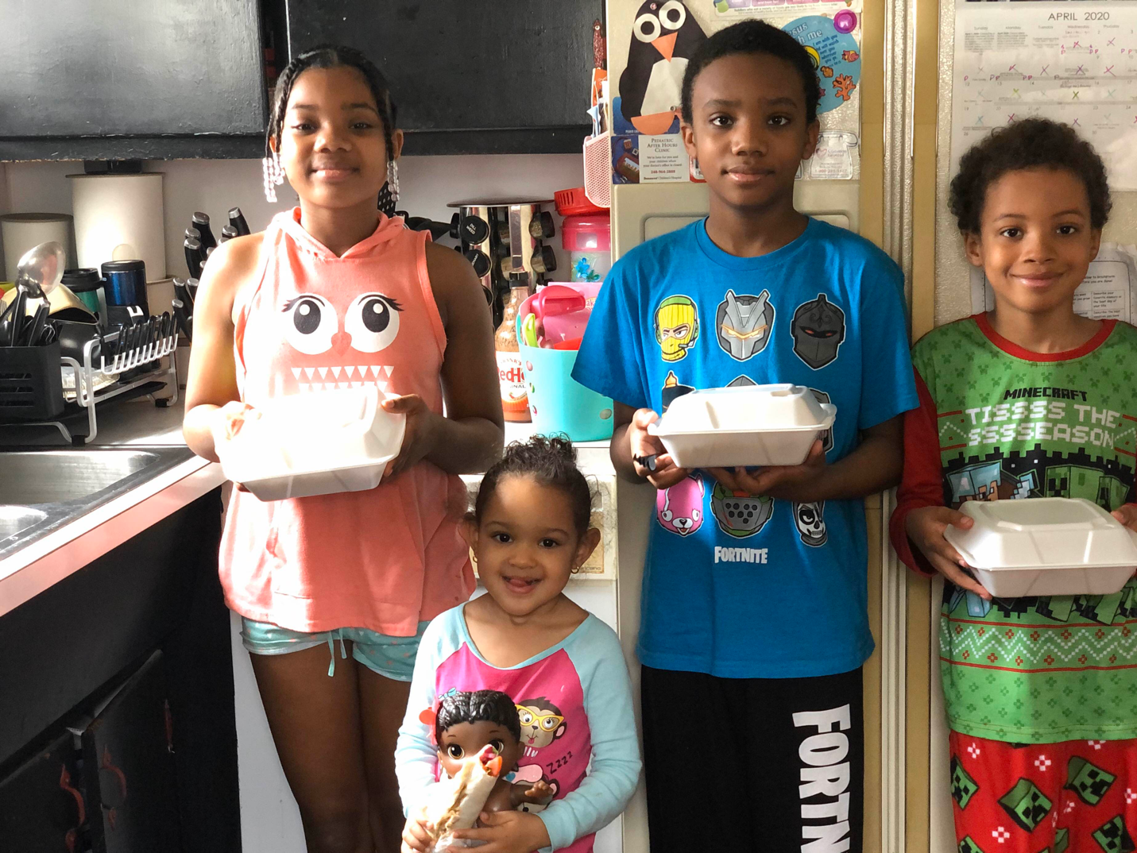

Appreciation email: 4/25
Hello
Wow what a wonderful meal you and Cedar Grille provided thank you so much! We spoke while I was picking up and I don’t have Instagram but I left a comment and recommendation on their Facebook page 😁
Anna

Appreciation email: 4/25
Thanks again mike , sadly I don't have Instagram and I tried to send a message from my gmail and it wouldn't let me I'll see if my other half can send a reply tomorrow thanks for everything you do we appreciate it
Will and family

Appreciation email: 4/25
Thanks again mike , sadly I don't have Instagram and I tried to send a message from my gmail and it wouldn't let me I'll see if my other half can send a reply tomorrow thanks for everything you do we appreciate it
Will and family

Appreciation email: 4/25
I can make a new Instagram account if that helps and again thank you so much for all your help and support during this pandemic and yes the food was awesome I really appreciate it so much it's hard being a single mother and having to make ends meet while being off of work and the kind donations helps lifts my spirits during these uncertain times thank you!!🤗🌺❤

Having trouble with the Instagram not sure how to message lol I don't do social media but I want to personally thank Cedar Grille- and Lefty's for their food donation for me and my family during these hard times. The job layoff, school closing, and trying to stay protected from this pandemic has caused anxiety for me and I am thankful for all the help and support. The food was delicious and the kids enjoyed!

Appreciation email: 4/26
Thank you so much for assisting me promptly
To help feed others that were greatly in need of food. It definitely lifted their spirits to know that there were kind people in this world that would stand in the gap and not let them go hungry
As I mentioned to you upon my arrival one person called while I was on my way there stating they were in desperate need!
I am assisting people from all walks of life a college student an elderly retiree and an elderly veteran who all take pride in providing for themselves but did not have transportation to get to any food distribution locations
in desperate times like these people they can fall through the cracks I am grateful you did not allow this to happen. I found your agency on the news
And you lived you to your promise
May God bless you and your obedience and kindness
Thank a thank you and thank you again
Dorothy

First email: 4/25
is this still available

Last email: 4/26
I wanted to say thank you for the help I received today. It helps more then you know being self-employed and outta work right now. It has been hard to pay the bills and feed my boys but this has helped tremendously. Thank you God bless

Appreciation email: 4/27
You guys are great. Im happy your helping

First/last email: 4/27
We were affected by the pandemic when my wife's hours were cute. They shut my work down until further notice back in the beginning of April. My unemployment at first was unsuccessful. I am awaiting payment with retroactive. We have been using our tax returns to buy meat. Unfortunately some of the sides like mashed potatoes, and other staples are hard to find. We have wic for our kids. My son is on soy milk and again can be hard to find as people are hording it.
Michael

First/email: 4/27
My name is Monica and I'm a disabled mother of 3 waiting on disability (put on hold) and was about to have serious lumbar back surgery (again put on hold & on bed rest now) right before all this began. We were doing OK until my their father quit paying child support at beginning of April because his plant shut down. So now I'm down to literally zero income and $30 left to my name. It’s been lovely having my children home from school though. My twin daughters will be graduating this year and heading off to college so it's my last few months with them. One is going into nuclear engineering and the other bio med. So proud. My son is going into 8th grade and just as smart. I can prove everything if need be. Thank you very much for your time.

First email: 4/26
Hi my name is ashley I l8ve on the east side of detriot mi I am a single mother of 5 kids I have been layed off work for over 5 weeks now due to this virus I have not got any unemployment yet and still waiting in food stamps they denied me so I file a hearing ke and my kids struggle every day to eat we have nothing my kids also without formula and diapers and wipes not tissu no sope trash bags dish sope laundry sope no money to wash I dont have a car my moter went out I am in all kinda bad shape if u could help me in any kinda way also phone about to be shut off and all my Bill's about to be due thank you so much have a blessed day

Last email: 4/27
Thank you so much for the food delivery you dont even know how much me and my kids appreciate it thank you so much

First/last email: 4/27
Hello. Thank you for helping families even if you chose to not help mine. We are a family of 5 . With the schools being closed the kids dont get their free breakfast and lunch. It's been very hard cause we dont get a lot of food stamps. I try to get the easy stuff so I know we will be ok. I think the kids are tired of it already ( they dont understand). If you could see it in your heart to help us it would be much appreciated.
Jennifer

First email: 4/27
Hello, my name is Karie.
I'm a single mother with 2 kids. I Have not been working due to the epidemic we are currently in. I've applied for food stamps, however, with the system being so bogged down the process is very slow. I've applied for unemployment and next week will be week 2 for calling in my claim as this is a bi-weekly process. I have not yet recieved my unemployment. In addition to this my sister’s husband unfortunately has been diagnosed with covide-19, they have 3 children. We had everyone tested and once confirmed they were not positive all 3 children are now staying with me and my kids until their dad is better. This has put a huge strain and stress on me. The biggest stresser I have is the food situation. So when I came across this I'm just praying it’s not a scam. If not a scam how can I be blessed with this.
Thank you so very much.
God bless

Last email: 4/27
Oh my goodness what a blessing wow what time do you go until I'm coming from St Clair I hope that doesn't hinder my ability to get help
Kare

First/last email: 4/27
Hello, how are you today?
I am a Painter whose not been able to get thru to get unemployment going on the 3rd week!! I have run out of money I had from a job I finished just before the lockdown and have been fortunate to do a few interior doors for an old customer in my basement.
The little money I got from the doors has gotten helped get me here but, I need help with food. I do not get assistance and I have a 5 yr.old son. Any help would truly be appreciated and I KNOW you will be blessed if you are able to still!

First/last email: 4/27
Hello
A friend of my sons has lost an aunt & uncle to Covid-19
Food is low at their household 😢
I can pick-up and deliver to them if you have some food to donate.
Thank you, Holly

First/last email: 4/27
Hey seen your Ad tonight and was curious on how I can get some, I’m the middle child of my family we all live together I have two siblings 24 and 18 and we all work and take care of our mother by working, coronavirus has slowed down our incomes well are most consistent ones we, work on cars, sell shoes, do yardwork in the meantime til our jobs open back up, my name is Justin

First email: 4/27
hi im in need of food i am laid off because of corona i have got my car repossess no money at all yet it’s very tight

Last email: 4/28
Hi im Charmaine i am emailing to let you know that i really really appreciate my care package for my family you guys are the Best Thank you all and bless you all Charmaine

First/last email: 4/28
I didnt receive a check from the gov.
I was sick and im out of work .lucky my kids are grown but live away .I see spending there check on new tvs and lawn goods ...im hungry.

First/last email: 4/28
I am taking care of 3 of my grandchildren which their mother is recovering from the covid-19. kids ages are 5,4,and1 years old.I am in need of food. It would be highly appreciated. Thank you.
Denise

First/last email: 4/28
Hello my names darryl im 32 with 3 beautiful sons i could really use help with any kinda food for me and my son the covid 19 has hurt me pretty back cuz i been laid off for a few weeks so i can’t get the extra food i need for my sons i dont got a car to get around and im not getting food stamps cuz of me working before this stuff happen me and my sons could really use the help with the food or anything else we are able to get help with thank u so much for reading

Appreciation email: 4/28
Hi Everyone!
You're welcome! Thank you for your generosity. I told him about the package I've put together with your help and he is overwhelmed and grateful to you for all you have done.
I saw you posted again, and am wondering about the distribution time. Let me know, and thank you so much!
Jay

First/last email: 4/28
This virus has wipes us almost completely out of food and diapers I have 2 kids ages 5 and 2 who have learned what it's like to eat whatever we have and not complain but it has also made us stronger as a family to have gone through what we have in such a fast time

Appreciation email: 4/28
Thank you 🙏 for posting this and helping people.

Have an amazing year.

First/last email: 4/28
Hello im Jason Ive been living in a hotel since march 12th and it has taken a dramatic toll on me... I was supposed to go to transition housing and everything was closed down. Im working right now but yet still do not have enough for food.. If you can please help with anything that would be greatly appreciated.. I have also taken in a couple with a service even though i cannot afford it.. Please please help.. God bless for all that you are doing

First email: 4/28
Good morning my name is marlicia I lost my job due to the virus and I recieved income but only enough for my car insurance n rent please anything will help

Last email: 4/28
Ok, I'll be there. My name is marlciia do you have an address

First email: 4/28
im a single mom have a big family and not working right now cause of covid19 i baby sit and take kids to school pick them up and baby sit babies and kids now i can’t do that i can’t find a job cause i dont have anyone that can watch my kids while i work
Jessica

Last email: 4/28
Ok thank u so much hun see u tomorrow

Mike Vissotski’s email: Fri 4/17/2020 8:35 PM

Hi Again!

We just received 15 crates of baked goods from Nino Salvaggio’s. If you are interested in coming tomorrow 11-2 please let me know.

Reponses:

Fri 4/17/2020 8:38 PM
Hello,
Yes that would be terrific thank you so much I will be there.

Fri 4/17/2020 9:02 PM
Yes Im interested, I can make it
Around 11:30. Thank you so much, you have helped my family out so much and I’m so grateful.

Fri 4/17/2020 9:08 PM
Thank you for considering me for this generous offer. Hopefully if you have another time I will be free.

Fri 4/17/2020 9:13 PM
Yay thank you so much! I will definitely be there!

Fri 4/17/2020 9:14 PM
Yes, would very much like to come in for the food. Thank you so much!!! Also, thank you for emailing me. Sincerely, Matt

Fri 4/17/2020 9:22 PM
Yes thank you so much 😊. We will definitely be there tomorrow.
Thanks,
Amy

Fri 4/17/2020 9:24 PM
Okay I will be there... Oh my gosh thank you so much

Fri 4/17/2020 10:09 PM
Hey! I totally am!! We could use some baked goods! I will swing by tomorrow. Thank you so much!

Fri 4/17/2020 10:21 PM
Ok awesome we will definitely be there. Thank you very much!!!

Fri 4/17/2020 10:24 PM
Hi, Michael,
Thank you so much! I will go tomorrow. We appreciate your great kindness and help! God bless you!

Fri 4/17/2020 10:33 PM
Good evening-
YES I AM INTERESTED
Fri 4/17/2020 11:00 PM
Yes I will be there! Thank you so much for reaching out & remembering me. Greatly appreciated! I will hopefully be driving wife's car a blue Ford fusion. I have a big blue F350 diesel named big blue pig lol. It's going to take me forever to recover from this pandemic if I'm even able to you know. Just started my car hauling business not even a year ago I'm the little guy trying to compete with the big guys who can do six eight cars at a time I can only do two. We'll see.. I will see you tmrrw around noonish!

Sat 4/18/2020 7:56 AM
OMG thank you so much for thinking of me. I just received this message this morning I was on line until 11 last night . I wish I would have received it. I do live quite a ways away at least 40 miles I would really love to come I will let you know in a couple of hours thank you again that is so so thoughtful. I could sure use it. Thank you sincerely Tina

Sat 4/18/2020 9:20 AM
Hello yes we are interested thank you! I’ll try my best to get there

Sat 4/18/2020 12:48 PM
Hi Mike,
I wanted to thank both VIMA and Nino Salvaggio’s for the wonderful goodies. My family is continually grateful for the generosity and is already enjoying some of the sweet treats.
Warm regards,
Claire

Sat 4/18/2020 1:04 PM
Thank you nino’s , might not seem like a lot but by giving out food to families in need at a time like this is helping and making a difference in how we’re going to make it through this. I want to thank you Michael again for taking time out of your day to organize and get food to families.
Than you nino’s and Michel.

Sat 4/18/2020 1:10 PM
Thank you so much for the baked goods and ham. Your generosity is greatly appreciated. You've been a wonderful blessing. My family is truly grateful.

Sat 4/18/2020 2:44 PM
Hello, I would like to thank you again for the free food from Nino Salvaggio's.
This came at the right time to ease my strain from the financial crush from being laid off. Being a single mother to two young boys under 5 has its challenges and the frustration trying to apply for benefits to stay afloat and trying to reach unemployment has been draining. This came at the right time for me and my family and I can't tell you how much I appreciate the help Thanks!!!🙂🙂

Mon 4/20/2020 6:08 PM
It was a pleasure meeting you. Thank you so much for your wonderful donations. Teresa and the kids were over the top about the pastries from Nino’s along with all the other great food given. Please send our warmest regards to all of those involved. This helps my family beyond measures. It makes my heart smile knowing that there are such good people out there willing to help others especially during such devastating times. You are all angels!

Warmest wishes from our family to yours!

Teresa, Dominic, Jeffery, Bella, Tony and Aunt Karen :)

Fox 2 News response emails

First email: 4/22
To whom it may concern:
I am on Social Security Disability, and cannot make ends meet (as my rent takes more than half of my monthly check, and my bills are barely paid). Unfortunately, at this time, I cannot make ends meet. If there is help with food could you please let me know? I saw this on the Channel 2 news station. I know my son (29 y.o.) just moved into a sober living home (on Monday) after rehab and is interested as well.

Thanking you in advance for your time.

Second email: 4/22
Good morning, Michael!
Yes please! I would sincerely appreciate it. Is it possible for my son as well? I was going to pick him up at 1pm from his sober living home (in Roseville-he is helping me by steam cleaning my apartment today)..we can be there by 2pm, if that's okay? Thank you for your quick response! Have a fantastic day!

Last email: 4/22
Hello Michael,

We would like to thank you for your help with the food today! This is an amazing way to help those of us who are struggling during this time. We are going to cook that ham, and make some meals for our neighbors who couldn't make it out to you today (our way of being able to pay it forward). A wonderful compliment to the food was the wine! Amazing!

Again, we want to say thank you to you and your company (VIMA) for taking the time and energy of reaching out to companies to donate their products! You're an amazing person!

Keep up the great work! We're telling everyone about how kind and generous you (& VIMA) are!

First email: 4/22
I saw on the Fox 2 news your giving away food for families in need. Please contact me.

Last email: 4/22
Thanks so much for the food bag you gave to my family. We appreciate it so much.
Angela

First/last email: 4/22
I saw your clip on tv. I’m wondering if I could apply for your food giveaway. I am a single mom with a college son. I lost my job due to covid and have not received any unemployment as of yet. I’m hopeful, but the reality is I don’t have any income right now. Please let me know if I would qualify.. Thank you for your kindness.
pam
First email:
Please contact me for food pick up. I saw on FOX 2 that your giving away food to needy families.
Angela jones
Karen M first email 4/22/20
I saw your ad in Craigslist and found this email address on your website. My family does not have a vehicle and most food pantries only put food into cars; where I used to go closed down due to Covid-19 so it's quite challenging.

I would very much appreciate any assistance as finding work after a surgery has been quite difficult.

It's a blessing to know there are companies like you out there! I hope to hear from you soon.

Thanks, Karen

Last email 4/23/20
Just wanted to let you know that I received the packages!!!

Again, thank you and your team of those doing good with you!!!☺

First/last email: 4/23
Hello, my name is Anitra Hicks and I just want to thank Mike @ Vima Wealth for his kindness and generosity in this crisis! I am a nurse and was diagnosed with Covid19 and pneumonia and was hospitalized for 7days. If God had not woke up to use the bathroom I would’ve died in my sleep. I woke up to blue lips and blue fingernails which is called hypoxia. Thanks to the quick response of the 911 operator and 1st responders, they saved my life. I want to thank Fox News for airing the information of the great things Mike @ Vima Wealth is doing for all of us! I had the opportunity to meet Mike as I picked up my care package and he is truly a genuine and caring man. The package really will help my family, I even got wine 🍷 Lord knows we need something to help us relax lol... Thanks again Mike and Fox for airing the good deeds of Vima Wealth!
Sincerely,
Anitra Hicks
Sent from my iPhone
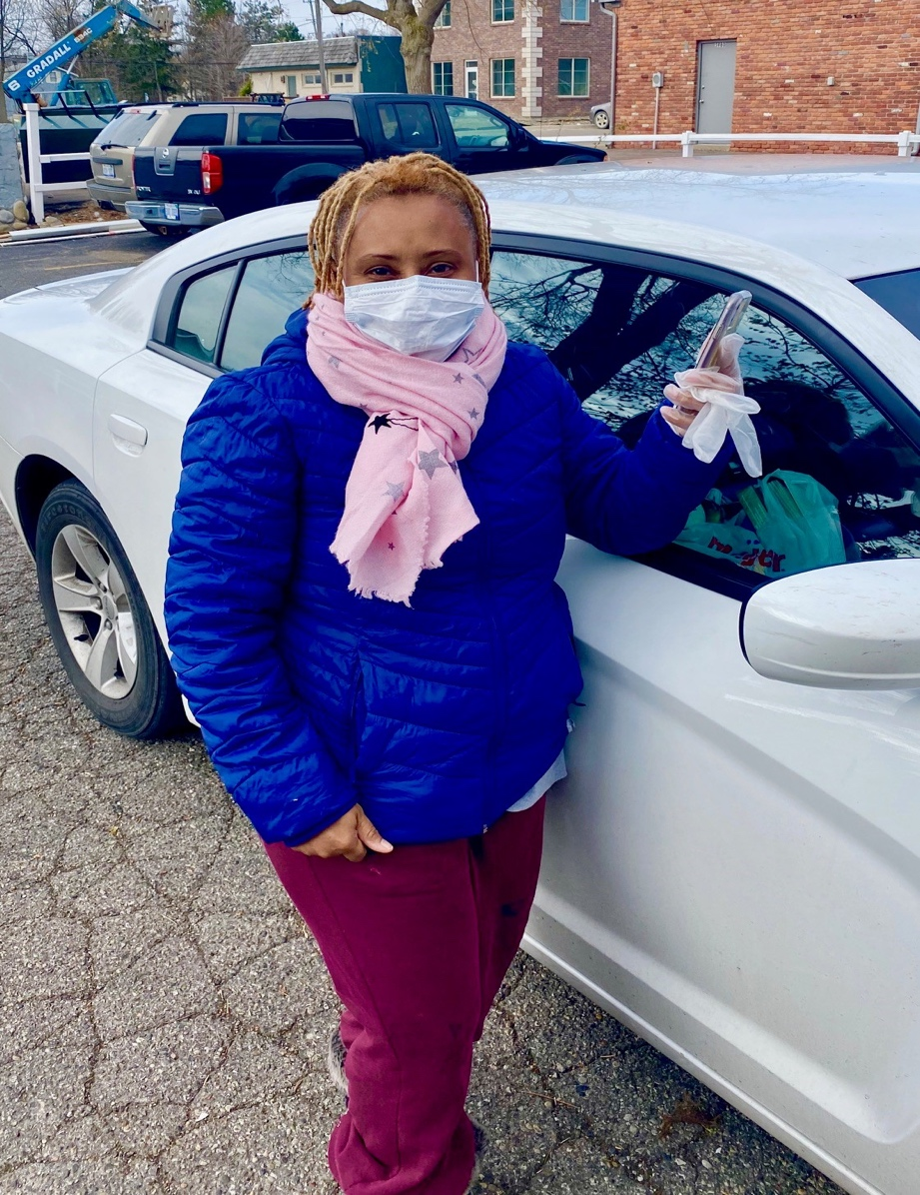

First email:
Hello,

I would like to receive a care package. I wanted to know what I have to do in order to receive one.

Nika Womack

First email: 4/23
If any care packages are available please let me know. Thank you in advance!

First email: 4/23
Good afternoon . I'm Sylvia. I would like to pick up some food for my family plz n thank u.

First email: 4/23
I am in need i have 5 children I also have my disabled brother im taking care of
Jenny

First email: 4/23
Good Morning -
How do I go about setting up a pick up time and place?
Thank you very much for doing!
We have four children, my spouse and I.
Rhonda
Last email: 4/23
Michael -

Thank you so very much!

My husband, Michael, will pick up.

Thank you again.

Rhonda

First email: 4/23
Hi,
I would like to arrange pick up of a care package. I am able to pick it up anytime.
Thank you,
Last email: 4/23
Ok thank you. This is going to be very helpful to my family. See you around 1.
First email: 4/23
Good morning, do you still have food available?
Thank you
Last email: 4/23
Yes Sir, I will be there! thank you again
First email: 4/23
Hi Michael I was emailed by a friend and I told about your care package is there any way I could be considered.im sorry my name is Anthony.could you text me when you have time?
First email: 4/23
Hi is there any food still available? If so what time and where would I be able to pick it up?

Carrie

Last email: 4/23
Yes, I will be there. Thank you so much Michael!

First email: 4/23
I’m interested in the food card package if it’s still available

Last email: 4/23
Thank you so much for your kindness and generosity I really appreciate it

First email: 4/23
Please give details on picking up care packages. Thank you.

Last email: 4/23
Hi Michael,
My Mom and I would like to thank you very much for the donation of food to us. We really appreciate it as it is so risky to shop for groceries at this time. Thanks so much again!
Sincerely, Terri and Marilyn

First email: 4/23
Hello,
I was inquiring about your food pickup. I would like what is a good time to pick it up and if I can set for my household and my elderly mom which is in a separate house. You can contact me Gia on this email and by phone

Thank you for your time.
Gia

Last email: 4/23
Hi Mr. Vissotski,

I am definitely trying to make it today before 2. Will there be a pickup tomorrow? If so are the times the same? My mom isn't available until closer to the 2pm time. If not, what are the other days? Please let me know.

Thank you so much
Gia

First email: 4/23
Hi there

Can I pick up some food Thursday afternoon? Thanks

Kay
Last email: 4/23
Mike

Thanks much for the bags of food from VIMA, we appreciate the help during this hard time with sick people and young kids at home .

Take care,
Kay
First email: 4/23
Hello Michael,
A friend of mine informed me that you were giving care packages to people in need? Is this something I could pick up for a family I know that is struggling? LMK? I would also like to say thank you for all the people you are helping at this time?

Roger Inez
Last email: 4/23
I don’t know why the email took so long to get through but the eagle has landed! Karen and her husband were thankful for the delivery! If you need a couple deluveries tomorrow just let me know?
Roger

First email: 4/23
Good morning,
My family of 8, my 5 children, my son's best friend and my brother, are in need of food.
Two of us are waiting to hear back from unemployment. My hours was recently cut to 20 hours a week, which is my household only source of income right now. I have no idea of how I'm going to pay my mortgage, water bill, car note, or any other bills next month.
Please help my family with food. It would truly be appreciated and a very big help.
Thank you and God bless,
Keena
Second email: 4/23
Hi Michael,
I just wanted to thank you for providing my family with a wonderful well needed meal. I am very grateful and I truly appreciate it.
You are a genuine person and may God bless you and always have favor for you.
Be safe and healthy.
Thanks again
Last email:
God bless! 😊
First email:
We’re is this located?
Last email: 4/23
Hi want to thank you so much for the gift of giving. This meals have brought joy to our family. We hope that you can continue to help others the way you are doing. We would like more families to benefit from this has this is a hard time for us and families that surround us. Thank you so much.
First email: 4/23
I would be interested in food if it’s still available. Thank you
Last email: 4/23
Perfect! How Do I go about pick up?
First email: 4/23
Hello,
A friend passed along your information and told me that you are giving food away. I'm not sure whats need, or if this is true. I appreciate your generosity and thank you in advance.
Roza
Last email: 4/23
Mr. Vissotski,

Thank you so much, you have no idea how much this means to me.

Roza
Mia D 4/30/20
Hello,
My name is Mia, I’m a 21 year old single mom. My son Chandler just turned 7 months old. COVID19 has impacted our family drastically. Chandlers dad had no choice but to leave college early his sophomore year which was nice for him to see chandler more but it has been harder for him to understand materials and focus since there is no longer a physical class to goto. I have not worked in almost 2 months now, I’m a server in Bloomfield hills. My work was shut down March 15th 2020(the moose preserve). I have not received any of my unemployment benefits, I am behind on my bills, I can’t afford little things anymore let alone diaper cream and days are starting to blend together.
Appreciation Responses from the weekend of 5/2

Walter A. 5/2/20
Hey Mike just wanted to say thanks for everything again! Truly appreciated.
Keep up the good works!

First email 4/28/20
Hello mike this is darryl again i got my mom and dad coming to pick up the food in the morning time around 8 am i will call u as soon as they leave there house they are coming for me cuz i got a job to do tomorrow morning and they are the ones with a car so they are picking up for me but like i said they will be coming around 8 am here is my moms number so that way u got it i will be having her call u when they get to your address but i will be calling you to let u know they are on there way to your work thank you very much you have no idea how muxh this helps me out
Darryl my mothers name is Thelma and dads. Name is Darryl Sr i have 3 sons so this helps ms out alot my sons ages are 8 which isnt my blood son but have been in his life since before the day he was born so he only know me as his dad snd looks up to me as his one and only dad and he will always ve my son his name is Connor

My 7 year old is my first born blood he had the same mother as my 8 year old i get both boys thursday till sunday night they are my world but keep me a busy dad his name is Darryl 3rd

And my 18 month old son i only get him twice a week he his by a different women and me and her dont see eye to eye im working on getting a DNA test to make sure he is mine and if he is i wilk be going to court to set up days where i get him his mother doesnt want me part of his life bcuz we dont see eye to eye and she thinks i should put him ahead of my other sons but i told her i wouldn't do that i treat all my kids the same way a d will not treat any if my kids better then the other and she didnt like that so we split up anf i feel that was the right thing to do no mother or any person should ask me to put one kid ahead of another kid knowing that they are all my kids and if they feel different then we shouldnt be together no women comes ahead of my kids and on top of it my 7 year old has a lot of problems hes on meds day and night he goes to class every day cuz he is border line autistic and also had to wear a helmet when he was younger cuz one side of his head grew to faster then the other side and he had a disease called goldenhar syndrome and it broke my heart knowing that she knew he had all this stuff wrong with him but still asked me to out my other child ahead of him idc whats wrong with my sons i will still love him like a dad should and i will not any kid of mine ahead of ankther child of mine but thats a lil about me and my sons anyways i will call u in the morning to tell u they are on the way and will have her call u when they are there thanks once again

Last Email 5/2/20
Thank u so much for the food and helping me and my sons out I didn’t care if I ate I just wanted to make sure my sons had food.
Darryl B.

First Email 4/22/20
Good morning,
My family of 8, my 5 children, my son's best friend and my brother, are in need of food.
Two of us are waiting to hear back from unemployment. My hours was recently cut to 20 hours a week, which is my household only source of income right now. I have no idea of how I'm going to pay my mortgage, water bill, car note, or any other bills next month.
Please help my family with food. It would truly be appreciated and a very big help.
Thank you and God bless,
Keena Washington
Last Email 4/23/20
I just wanted to thank you for providing my family with a wonderful well needed meal. I am very grateful and I truly appreciate it.
You are a genuine person and may God bless you and always have favor for you.
Be safe and healthy.
Thanks again, Keena
First Email 5/1/20
Yes I can be there thank you so much!!🙂🤗
First email Rosa 4/22/20
Hello, A friend passed along your information and told me that you are giving food away. I'm not sure whats need, or if this is true. I appreciate your generosity and thank you in advance.
Mike: This is true. Tomorrow I will be at the office 9-2pm. Please let me know if you can come.
Rosa: Unfortunately, I am being quarantined. So im unable to leave the house. I'm a nurse that worked on coivid 19 floor.
Mike: Sorry to hear that. Where do you live? We might be able to deliver
Nicole (Rosa’s Sister): Hello Mr. Vissotski, This is Roza’s sister, I am trying to catch up on all her emails personal/work and her children’s teachers, so please forgive me for the time lapse. I am here taking care of my sisters two daughters as she was admitted into the hospital last Monday due to the virus. I don’t know what care package you are speaking of, but I can say and help is offered at this point. I appreciate your reaching out and generosity. I ask for prayers also.
Mike: Hi Nicole, we provided a care package of food to your sister a couple weeks ago. We would like to deliver another one for her kids. Please let me know if that is ok with you.
God bless and prayers for your sister.

Nicole: That would be much appreciated. It would definitely help with things around here. Her girls (12 & 8) are terrified that their mom won't make it.
Last email 5/6/20
Hello Mr. Vissotski,

Yes we did, thank you. The girls appreciated the treats.

Nicole

Last Email 5/2/20
Hi, I would love to thank you again Mike and also the wonderful lady and everyone who helped me and my family ease some financial burden while going through this Covid crisis! The package was so nice everything that me and my kids love I'm very much appreciated for the help if I could hug everyone for their generosity I would lol 🤗🤗🤗. As you know the bills keep going throughout everything so my unemployment has to be spent wisely with rent, utilities, car insurance (which is high🙁), and nessacities like washing powder, tissue, food, etc...almost everything is completely gone afterwards. Having provided the basic necessities for me and my family which is the M0ST important thing has been a blessing! I appreciate the help from everyone! I hope everyone remains safe and pull through these tuff times pretty soon everything will come to past (Revelation 21:4) with sickness, death, hardships in life. Love and blessings from me and my family Thank You👩‍👦‍👦👋🏼🌼
First Email 4/27/20

We were affected by the pandemic when my wife's hours were cute. They shut my work down until further notice back in the beginning of April. My unemployment at first was unsuccessful. I am awaiting payment with retroactive. We have been using our tax returns to buy meat. Unfortunately some of the sides like mashed potatoes, and other staples are hard to find. We have wic for our kids. My son is on soy milk and again can be hard to find as people are hording it.
Last email 5/4/20
I have to say the last care package we received from one of your sponsors was a major blessing to us. This also gives us a sense of hope in the great disruption. I have now started receiving my unemployment and we are starting to do a lot better. My son and daughter loved the toys. My daughter can't seem to put the ball down for too long when she is outside. Thank you for everything you do.
Mike B.

First Email 5/3/20
It's great you are doing this. I don't need food as my family is all set but there's a single mother who lives in an apartment that was divided off in the house next to me with a teen daughter and 9 year old daughter who could use your help. I've helped some but it would make her day to get more. My wife or I can deliver it as well.

Also, there must be other families needing food delivered. I would be willing to help of you have any such requests.

James

First Email 5/3/20
Mike & Mike,
What great testimonies of your generosity and meeting folks' needs. There is something special when you do something like this for others, with nothing expected in return. The Lord sees your good works, but remember that we can only approach God when we accept & receive His Son, Jesus Christ as our Lord and Savior. This is what the Bible says in the New Testament

First Email 5/1/20
Thank you so much for this offer. We are pretty stocked up right now. If there's anybody that can't get out of the house or drive please let me know and I can deliver it to them. Might as well take advantage of the cheap gas prices!!
Regina

First email 4/24/20
Hey mike, yes I’ll be able to make it
And I have four people in house hold. Thank you

Last email 5/2/20
Thank you so much for the care package ,stuff from ninos and other things. You and the people that have been helping you are the light during these hard times with jobs and covid-19. Bless you and your family and anyone that helped you out. Thank you again my family is deeply grateful with what you have done for us. Danny

First email 5/1/20
Hi Michael I will definitely be there thank you so much!
Last email 5/2/20
I was so sad that I couldn’t be there. I asked my neighbor to take a look at my van. I think I might need a new battery. Either way thank you so much for making sure I got the package it was amazing! I really loved how they included a lunch and dinner menu. My daughter loved her bunny too! Thank all of you for helping me and my family. Hi Michael I just got my care package and I’m legit crying. The lady that brought it was so kind. I would like a chance to tell her and her family thank you for this. Words can’t even express the gratitude I have for them.
Jasel

First email 5/1/20
Thank you ! I will be there !

Last email 5/2/20
I would like to thank you from the bottom of my heart for the food for my family and I. It is really going to help. I found out yesterday I have to go pick up 3 of my grandchildren from Wisconsin and bring them back to my home here for a couple months. My daughter has to stay in hospital with another grandson! He has been fighting cancer for the last 2 years! He has to go extreme procedures since chemo and radiation has not work. Again thank you!
Anna Marie

Betsy 5/2/20
It's a beautiful thing your doing.

Matt 5/1/20
This is Matt Murray. I will be there to pickup the care package. Thank you very much. All of us here are very thankful for what you guys do.

5/3/20
Thank you so much for this offer. We are pretty stocked up right now. If there's anybody that can't get out of the house or drive please let me know and I can deliver it to them. Might as well take advantage of the cheap gas prices!!

5/2/20
Thank you so much for the care package, stuff from ninos and other things. You and the people that have been helping you are the light during these hard times with jobs and covid-19. Bless you and your family and anyone that helped you out. Thank you again my family is deeply grateful with what you have done for us. Danny

5/2/20
I would like to thank you from the bottom of my heart for the food for my family and I. It is really going to help. I found out yesterday I have to go pick up 3 of my grandchildren from Wisconsin and bring them back to my home here for a couple months. My daughter has to stay in hospital with another grandson! He has been fighting cancer for the last 2 years! He has to go extreme procedures since chemo and radiation has not work. Again thank you!

Anna

5/3/20
Mike & Mike,
What great testimonies of your generosity and meeting folks' needs. There is something special when you do something like this for others, with nothing expected in return. The Lord sees your good works.

5/1/20
Thank you so much! I'd love it! My kids love the end of the week because of your generosity.
I'll be there.
Thanks again,
Dawn
Charne 5/4/20
During this crisis I have lost my job I’m a single mother of two kids and my snap benefits are terminated it will be greatly appreciated for help

Anitra 5/5/20
Hello Mike,

I want thank you and show my gratitude for all you have done thus far with helping others in need. I’d also like to thank the loving couple who shared their generosity this Saturday with generous amounts of food, clothes and monetary gifts for families in need. Mike it’s people like you, them and the others that work together with you that makes the world a better place!
Thanks again,
Sincerely Nurse Anitra H.
Kayla 5/5/20
Hello,

My name is Kayla Sample and I am in need of help with food. I moved to Michigan about 3 months ago but am moving into my own place tomorrow. I am single mom of a little boy and a 10 yo and we are both on limited income. With the moving costs, currently no vehicle but pay for rides, just establishing residency, and the current lock downs..finding food and obtaining affordable food has been super difficult. Would your group be able to help? I'm moving to river rouge. My email is
Thank you for any considerations
Kayla Sample

Ayana 5/5/20
Hello my name tameika I'm on my daughter phone my email is or u can call me at --- a single mom who is going through domestic violence who now currently I'm out of work and need extra help with food or anything to help it appreciate

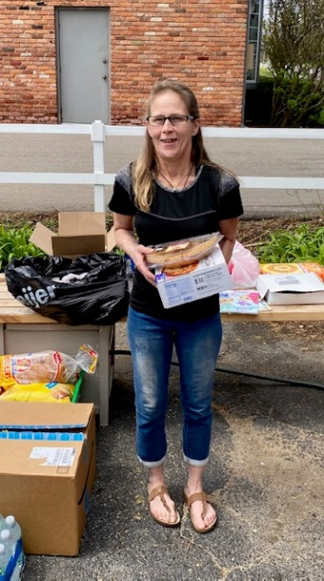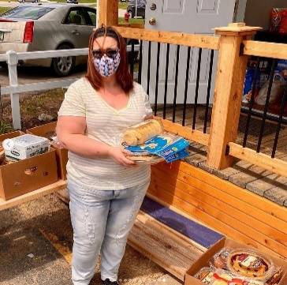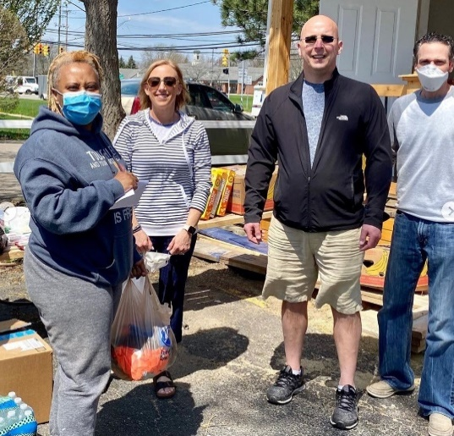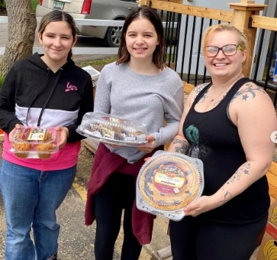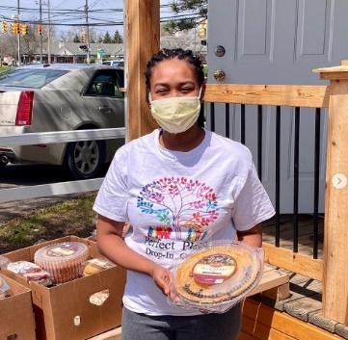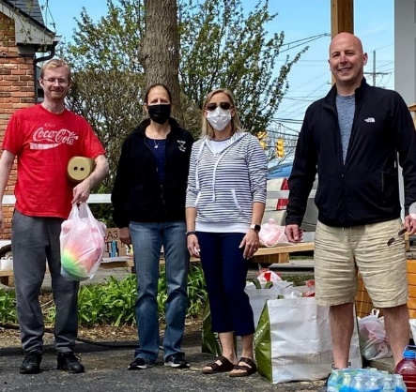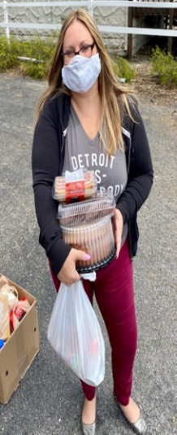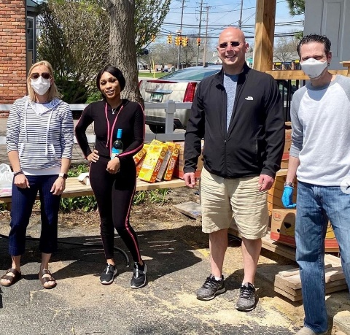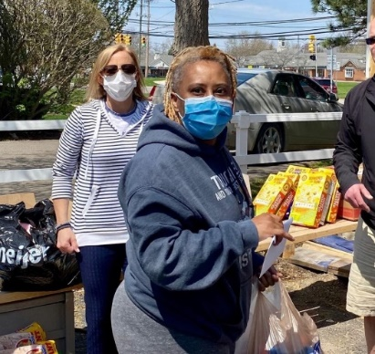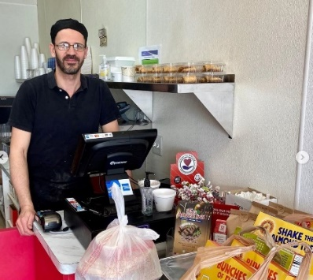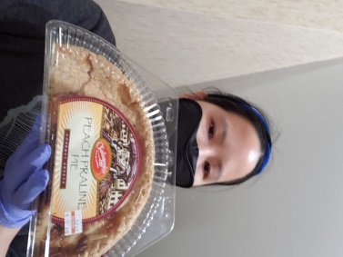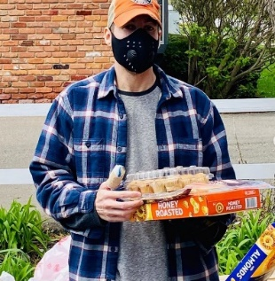
Keena 5/5/20
Hi Mike,
I just wanted to thank you and the awesome family that provided the food for my family. My little girl was so excited to see the fun stuff for her. It was more than I expected and everything we normally like to buy. It was like I went grocery shopping myself for my family. I'm forever grateful and I pray that this family continues to be blessed.
Thank you and God bless 🥰
Keena Washington
First email 5/1/20
This is Matt M. I will be there to pickup the care package. Thank you very much. All of us here are very thankful for what you guys do.
First email 4/22/20
Hi is there any food still available? If so what time and where would I be able to pick it up?

Carrie Shortway
Last Email 5/5/20
Hi Michael,

I want to give you and all who have donated food and other essential items we need a BIG thank you!

Covid-19 came in and shook our country up. Allot of us have been effected in a negative way! I am just 1 of many who have been let go for the, Stay at Home order! It's been challenging to say the least. I don't think allot of people take the time out to think about some of us who live paycheck to paycheck.

I want the people who have donated, even the simplest of things, how much we appreciate them! Your hard work and efforts do not go unnoticed!

I have a family of 5, 3 boys, a preteen and 2 teenage boys! Food is a necessity! I don't know how we would manage with out the help of our hero's that are making these donations!

So from the bottom of my heart, Thank you! Thank you for taking the time out to help, Thank you for the food and donations, Thank you for caring enough for our community!

Bless you all and be safe!

Carrie Shortway 5/6/20
Hello I could not find a way to make a comment about the food we received but I wanted to message you again and say thank you because it has given us the chance to not stress for a bit and to worry how we are going to come up with money for both food and bills during these times. Your advice and kindness meant a lot and we are very great full for this and what you are doing for people like me who need help
With food. Again thank you so much
First email 5/6/20
Hey I would really like to thank you for all the blessings that you have given me and my family with the cherish cherish donations of food to help me feed my family is goes so far for us you would only know may God keep blessing you and your company thank you wants again
Cassius
Dawn 5/6/20
Michael,
Thank you so much for the donation of food! It will make a huge difference for my family!
Due to Covid-19, my husband & I have been unable to work. We don’t qualify for unemployment (which doesn’t matter because you can’t get through to even apply). Then my husband was admitted to the hospital with congestive heart failure, making the situation even more stressful for my son (who has an autoimmune disease) & I. This virus has turned our life inside-out & we are so grateful to people like you who have found it in your hearts to reach out to people like us.
Thanks again & God Bless,
Dawn Turner

First email 5/5/20
Hi, It's Lisa, I've emailed you guys a few times. I seen your Ad again, I was wondering how long you'll be there today? and/ or will you be around tomorrow. Please let me know, Thanks
LISA 😉

Last email 5/5/20
Greetings, My Husband returned home a few minutes ago with All the goodies that you so Graciously offered. I know I sent you guys a Thank-You before but I just can't help expressing our gratitude.
We've both worked very hard all our life, and were not lucky enough to have supportive family. If it weren't for people like you, it's would be difficult to realize people are mostly good, with a few bad apples thrown in just to keep everyone on their toes.
It's because of people like you, that restore my faith in humanity. I sure hope that very soon we will be in the position to "pay it forward !".
You may not consider what your doing as that big of a deal, but I surely do.

With Warmest Thoughts,
Lisa and Chuck

P.S. Attached is a Thank-You Card, the face & inside of the card
From us to you!

First email 5/6/20
This coronavirus says put a huge strain on my family. Behind in rent behind in bills my phone is shut off because I don't have the money to pay. I have been going to different places for food such as the soup kitchen and churches. it's difficult being able to take care of things when everything is shut down and you have no income coming in. I don't know what I'm going to do when all this is over because I will owe so much money that I'll never be able to catch up. I'll continue to pray on it and hopefully everything will work out. My email address is at the top of this email.
. Thank you for your time and your services
Nick.
First email 5/10/20
Hi Michael!

As we mentioned in our instagram messages, your organization is doing a beautiful thing for our community. We would be happy to share your VIMA's story on Farmington Co-Work. We noticed while looking through your photos online that VIMA uses alot of space to organize the care packages, we have our Social room, here is a direct link to our space , we would love to allocate time for VIMA to use if this is something that would interest and benefit your organization. Let us know your thoughts!

Amra B

First email 5/11/20
Hello Mike,

You were kind enough to provide my family with great food some time ago.
And we all very appreciated that!
Unfortunately since then I was laid off.

Pete

First email 5/11/20
Hey I’m currently pregnant due any day and a mom of 4 already most of the food distribution around me has no food and because of the virus and I’m unable to work doctor wrote me off till September of this year if you have anymore food that I could come get I would appreciate it
Destiny

First email 5/11/20
Hi was wondering if I could get some food by chance. Mainly for my gdaughter. I have grand daughter living with me she is 6 and her mother, and my fiance. Fiance had a medical boot on and broken his leg several different spot. And I ruptured my achilles tendon and haven't been been able to see doc in over to months since I finish my therapy
Anna.

First email 5/11/20
Hi im interested in receiving help with food, im 8 months pregnant and i lost my job due to the corona virus and medical problems that are keeping me from work and im very short on money and food .my name is ronnie i can be reached at

First email 5/11/20
Hello my name is sarah and I'm going thru a hard time right now my daughters are 12 and 6 and my son is 3. My wife and I moved here in february 2 days after the loss of her older brother. Due to covid-19 we could really use the help with food wipes diapers anything helps please let me know

First email 5/11/20
I have not been able to work in 4 to 5 weeks the cupboards are bare and the family is just trying to tell me it’s OK but I know it’s not
Tim

First email 5/11/20
Good evening, hello again. I have received help in the past from you all there at vima. I was truly blessed. We are still beimg.impacted with the virus . I am still out of work and awaiting on unemployment or a return date. We are a family of 7.
Tarah.

First email 5/11/20
Hello. I messaged you recently about how awesome you guys are for what you are doing. I still believe that. I was wondering if you had any information about how I could find a place here in Owosso to help my boyfriend get some meat. He has cans and boxes of non perishables. I am not sure if the food pantries have meat around here. I'm not able to borrow my parents car a bunch. So I'm not able to go to food pantries right now. He only has a bicycle. Thank you.

Last email 5/12/20
No. I'm sorry. We can't.

First email 5/11/20
I been out of work since this all started and haven't got one employment check yet and have a son so its really hard thank you any assistance
Glen.

Last email 5/13/20
Im sorry i didnt see yor message till now my son had my phone if you can set up another appointment id greatly appreciate it i started back to work two days our of the week now but i could still use the help and im a mechanic if you ever need work done i will gladly help you in return thank you have a great day

First email 5/12/20
In need of food struggling with my wife and she is pregnant im part time just able to pay the house bill. Looking for food if you can help!!!!!

First email 5/12/20
Hi there my name is Sarah and I am a single mother of 3. Ages 6,5 and 3. We fled to Michigan February 7th and I could not get a job soon enough before COVID-19 took over. Now my children are out of school and I'm struggling to keep us afloat. We would be greatful for any food received!

Last email 5/12/20
I will have to try and find a ride. I'm not far from you about 10 minutes away but I wasn't able to get a car before COVID-19.
Thank you Michael!

First email 5/14/20
To whom it may concern,

I am reaching out with hope that someone may be able to help me with food assistance. I am 25 years old and I have a 6 year old son. Anything will be greatly appreciated i havent been able to find work since this lockdown. Sorry to bother anyone. Thank you in advance for anything you may be able to provide.
Last email 5/14/20
I was scrolling through craigslist, free ads. I dont have transportation at the moment either but i can have my parents bring me asap. Whatever date and time is best for you. Thank you so much for responding.

ok can I be on my way ?

Taelar.
First email 5/14/20
I am interested in the food drive you have going. When is a good time to come and pick up food? Are you doing it this month? Thanks

I am high risk for coronavirus because I am a cancer patient, my age, blood pressure and thyroid issues. I am very hesitant about going out and about to the grocery stores and basically anywhere. I am on disability and live on a fixed income. I pretty much stay isolated and at home to stay safe and always wear a mask if I go out. I’m hoping this lockdown doesn’t last too much longer. God bless and stay safe.

Last email 5/14/20
Any idea when you might make the delivery?
Pennee
First email 5/14/20
I just seen your add for free food. Do you have to live in troy? Me and my husband live in Detroit and have no car to get to food banks or anything. He is a seasonal worker and hasn't been able to return to work yet and we haven't got a stimulus check or anything like that so we are struggling bad. And we have our kids and grandkids living with us in our apt as well. If there is anyway you could help us it would be greatly appreciated. Or if you can help guide me to someone who can help it would also be greatly appreciated. Thank you for your time. Have a very blessed day.
Rochelle.

First email 5/14/20
Hi I saw your ad for free food for people affected by Covid-19. I haven't received a paycheck for several weeks now and the bills keep coming in. Me and my friend could use some help since we both are not working right now.

Thanks

First email 5/19/20
Dear Vima,

It is hard to ask for help. My husband and I have just found very humble housing after being homeless, being quarantined separately because he had a positive covid19 test result while we were housed at a shelter in Taylor, at separate locations. It was almost unbearable. Almost broke our spirit because we missed one another so much. Additionally, I was quarantined all alone day and night for two weeks with no cell phone while he was at a homeless men's quarantine ward in Detroit, which slowed our job and shelter search efforts exponentially.
Yes, we have been adversely effected by this awful virus.

We just got our phone turned back on so I have only begun my job search, which means I will get paid well into June once I do find work. We just ate the last of our small stash of meat tonight, used our last milk and eggs, along with any and all pasta and rice today as well. We had very little in quantities as I was hanging onto everything as long as possible.

We would be so blessed to receive a food donation. Thank you for reading

Sincerely
Ann & Marcus Jackson

Second email 5/21/20
Yay!I'm at the back door waiting.

Last email 5/24/20
Again thank you so much!!! And thank you especially for the coffee and wine 😊

Thanks so much
Ann

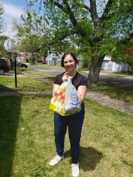
First email 5/19/20
Hi my name is Denise and this crisis has impacted me by the food prices sky rocketing. On a fixed income I'm not getting much for my money during this pandemic. Any extra food would be blessing. Thank you and have a wonderful night.

First email 5/19/20
Hello and thanks for your program wife and I are both unemployed just receive unemployment after 8 weeks and no stimulus so whatever you can do for us I'll be much appreciated thank you.
Last email 5/19/20
Thank you for the food I can't tell you how much it means that we can receive this gift today, and I will spread the word tell the people.
First email 5/19/20
HELLO , OUR LORD IN HAVEN WILL REWARD BIG , FOR YOUR BIG HEART , I WILL INCLUDE YOU IN MY PRAYERS TONIGHT .THANKS A MILLION .
First email 5/20/20
Hello.
I saw your post on c.l and was hoping to get some food assistance. We are a family of five and do to losing our jobs it's just been really hard to have enough. Any type of help would be greatly appreciated.

First email 5/22/20
I need this please.
Kaycee

First email 5/22/20
Hello,
I help take care of my brother who is unable to work because of a disability.I usually bring food to him.
Currently I am unable to work because of the pandemic. Any help we would be so appreciated
Warm regards,
Claudia

Last email 5/24/20
I wanted to reach out and thank you, your partner and all the sponsors. I split my care package with my brother. I found things I would normally buy from Costco. Love Costco. I have always worked and had income. It's difficult to be in a position to need. Thank you for being so gracious. Thank you for all your efforts to help our society during this crazy time. I hope you realize your efforts are making great impacts on us from the food itself, to showing us all that there are people that see a need and have the desire, initiative and ability to help and then put it into action.It's a great example of how we should help each other as we live out our lives. Bless you,your families,the people you help and your business.
Warm regards,
Claudia

First email 5/22/20
Hello my is ronnie and I'm in need help with food It's four in my family I applied but they to me I was denied food stamps so I've been donating plasma to food my family but found out I was diabetic and could no longer donate I need some help Thank you in advance.

Last email 5/23/20
I'm on my I'll be there by 2:15

First email 5/23/20
I been affected by coronavirus because I’m no longer working don’t have income coming in at this moment in I need to feed my family
Maria.
First email 5/23/20
I been affected by coronavirus because I no longer receive income at the moment because my job is non-essential.
Darold.
First email 5/23/20
Hello my name is Melissa. My daughter is 16 & my husband is off work til further notice. We got denied for food stamps & we are literally starving
Last email 5/24/20
I caught a flat tire on the way there this morning I just got it fixed & desperate need for food can you please call me.

First email 5/24/20
Hi I was just getting back on my feet from an illness, when Covid 19 hit and I lost a part time job that helped sustain my family. We could use some food if still available. Thanks Lisa

First email 5/24/20
Thank you for the opportunity to receive free food. My family and I have been tremendously affected by COVID-19 and life situations in general. I was previously struggling with 2 jobs before hand & just barely making ends meet. Currently I am laid off from 1 of my jobs & not able to receive unemployment. I currently work part-time at McDonalds but only for a few short weeks because I recently found out that I am expecting AND a high-risk patient so I'm not allowed to continue working throughout this pregnancy. My husband and I are caring for a family member of his and getting NO support so it's a struggle at this time. Our basement flooded with the heavy rainfall on Monday and damaged our hot water tank so we are struggling with that as well. I could go on and on but I won't waste your time. If you wish to consider me, my name is Ebony.

First email 5/25/20
Hi thank you for your help.
This has been horrific for me and my family. I’ve seen first hand how devasting this disease can be. In addition, My family is torn apart because of my health and the need be isolated from my loved ones.
God bless all of you and be safe.
Linda

First email 5/26/20
Hi, Our family could really use some help with food if you have any left. We are very thrifty in general but are really having a difficult time. We were having a bit of a rough time before the pandemic but now it's much harder now. We have a large family so a gallon of milk lasts us 1 day, 1.5-2 dozen eggs for breakfast. It's getting harder to keep up and feed the family. Any help would be greatly appreciated.

Last email 5/28/20
Thank you for getting back to me. I woke up yesterday to my tire flat on my car. My son has to take my vehicle to work until his is fixed. We have 4 of us sharing 1 car. We all have vehicles but unfortunately in a matter of weeks they all have issues. My son gets home between 1:30-3:30. If he gets home at 1:30 then I can probably get there by 2. I'm sorry I would not have bothered you if I knew I'd have transportation issues. Can you please tell me your hours for pick up Friday and Saturday. Thank you

First email 5/27/20
Me and my family live in a hotel that cost 300 a week. There is me my fience and our 4 kids. Since covid 19 started i had to switch shifts at work with shorten hours that brought my pay down to 324.00 a week

First email 5/23/20
Hello my name is Melissa. My daughter is 16 & my husband is off work til further notice. We got denied for food stamps & we are literally starving.

Last email 5/28/20
I will be there before 2 o’clock today thank you so much

First email 5/28/20
Hello my name is Jennifer and I'm in need of getting help with food

Last email 5/29/20
That would be great, thank you!

First email 5/29/20
We have been struggling to get help with food and other things due to not being able to get a job.

First email 5/29/20
Hi I’m currently homeless and my job is on stand still due to the outbreak. is this offer still going I’m in need of food

First email 5/29/20
I’m contacting for the help with free food. My name is Nicole I'm in Warren.

First email 5/29/20
Hi! My name is Alek Lyatker. I'm taking care of my elderly parents. I had to shut down my business because of the pandemic. I would like to pick up some food for my parents. If would help them alot! To schedule a pick up, please contact me

First email 6/1/20
Hello my name is Katie I'm a mother of 5 kids an could really use help with food 3 of them are teenagers so they eat alot thanks so much for being so kind during this crazy time we live in Sanford
Thanks so much

First email 6/1/20
Hi. I could use some help with food. I live in Midland county. Coleman

First email 6/1/20
This crisis has affect my family I can not work at this time I have under line health conditions my doctor has taken me off work

First email 6/1/20
I would love to be considered for some food.

First email 6/2/20
Hi,
My little family of 5 has been impacted severely. First I lost my job because of Covid-19. Then my husband was furloughed. Then his brother and girlfriend need to get out of Iowa so they moved her to live with us in Michigan and the same time all this was happening my brother lost his home to fire. So now I have myself and four adults and a puppy living in my two bedroom house that is probably 1000sq ft. On top of that I was getting SNAP but because my unemployment puts me outside of the income bracket I lost those as well. Please help us.

First email 6/2/20
Vanessa Maxson needs any and assistance please and Tysvm. She's a single mom and neen devastated by the flooding!

First email 6/2/20
Hi my name is Charita the crisis hit my family hard first my child school closed which forced me to quit my job to stay home with her second my bills got behind now the state saying they cutting off my food stamps I’m in need of help please feel free to call or text. Thank you in advance for whatever help you can give.

First email 6/5/20
Ok. Yes. Thank you for letting me know.
Last email 6/6/20
Thank you so much for helping people out in a time of need! We appreciate it very much and are very grateful for what you all do. Have a great day 🙂

First email 6/5/20
Hello, yes I can make it thanks!
Last email 6/6/20
Good evening Mr. Vissotski, I wanted to thank you again for the food donation that you provided for me and my family. Any amount helps and I am again very grateful and appreciative that you are able to support me along with all the other families out there in this time of need. When outside before at VIMA I talked to a couple of the families and its amazing that you are able to take out your time and resources to arrange help to suit all the families and their unique situation. I am dealing with issues with my unemployment so I am so happy that you are able to continually help. I'm sorry that I am not good at expressing myself in person I tend to don't do well in that area with meeting new people but better expressing myself in writing. Being extended this help doing good for others always teaches me to pay it forward in ways that I can provide in my situation such as clothes donations and support for the ministry that educates people about the Bible and the future that you can find answers to at JW.org. You are a very caring person and I want to thank you for everything that you have done. I also wanted to extend a thank you from my 2 boys Tayshaun and Quinton ages 4 and 6. Please again stay safe please during this pandemic we can't let our guard down and never be to protective with our selves. Sending you a virtual handshake and hug for everything take care🤗👋🏼🌼❤🙏🏽

First email 6/5/20
Hi Michael I’m sorry I’m just now seeing this is it ok if I come still?
Last email 6/6/20
Hi Michael I wanna say thank you guys so much for the care package today. Because of y’all we got to have a nice picnic at the park, and the kids are so excited to have pancakes for breakfast in the morning! We appreciate all that you guys do more than you know. Especially now that I have an extra mouth to feed due to some really sad and unexpected circumstances. I hope that you guys keep doing the amazingly kind and giving things that you do! And if you guys have any other care packages in the near future please let me know. My youngest daughter will be turning 4 on the 26th of this month and I would be more than happy to come and get anything you guys have or don’t need for her! I hope and pray that you guys continue to bless people! Please stay safe, and thank you again from my family to yours!
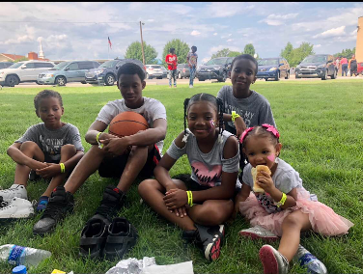

First email 6/5/20
Hi Michael,

Thank you, yes I can be there. Is it possible to get an earlier time? I can’t be in the sun. If not it’s ok I’ll layer up lol..
Thank you for your help and consideration.

Take care,

Linda
Last email 6/6/20
Dear Michael ,

Thank you again for your thoughtfulness and time and everyone that is giving of themselves.

Take care,

Linda

First email 6/5/20
Hello, good morning yes I can make it tomorrow. Whatever time works for you. Thank you again for all the hard work.you guys do. You are all truly a huge blessing to others.

Last email 6/8/20
Thank you guys again so much. The help received is so amazing and truly blessed the family.

First email 6/5/20
Thank you i can be there before 3pm like 2:30pm let me know if that works
Thank you again

Last email 6/11/20
Thank you,
This is an amazing blessing. In a crazy pandemic time your sources provided care for families like mines. The Robinson's family Thank you for taking the time to make something Great happen for others.

First email 6/15/20
Hello, I am responding to your ad on Craigslist. I am in need of food donations. I have been forced to stop working through this crisis due to my health conditions. I am on unemployment but they have stopped payment on me for ID verification and I was not paid the 2 weeks before that (I can provide a screenshot to show that). I have sent them the required information and they still have not cleared me. Any help will be appreciated. Thank you.

First email 6/15/20
Hello, omg where do we start? This situation has totally be the most difficult challenge that my family has ever endured. I have personally had to take a family medical leave due to my 80 year old mother suffering from dementia and didn’t qualify for unemployment because I wasn’t currently on the payroll, I have a 20 year old son that had to return from college in Illinois when all this broke out. Anything that you could provide would be much appreciated.

First email 6/15/20
I recently moved in to a new home I’m not receiving food assistance yet nor unemployment. I’d appreciate some assistance if still available.

First email 6/15/20
Hello my family is in Westland. We have been on limited food for over a month. Husband is the only one working. But after starting last week our checks are 250 a week. With bills coming up and still owing half the rent we are still struggling to feed all 5 or us at every meal. We make sure the kids eat first and both adults take turns with meals. Our stimulus paid the bills but didn't have much for all the food we needed. We could use a little help with food to feed two adults and three kids age 11, 7, and five.

Last email 6/16/20
Yes i can come just got to load up hubby and the kids.

First email 6/17/20
hello lm a veteran and really need food for me and my son, Barry is my name

First email 6/17/20
Hello how are you doing ... I will be honest I have never had to do anything like this before and not sure exactly how to go about it so I apologise if I am not exact on what you would need from me and if there is any other information you would like to know I would be more then happy to tell you everything you need to know . Me and my fiance both lost are jobs due to covid and it is tuff on us but we managed to get on unemployment but we recently have had some major issues trying to verify are unemployment and it has been 6 weeks now and I will be honest we are completely out of options on how to make ends meet. We have Ben trying to resolve some identity issue with unemployment but it is taking suck a long time and in the process we are completely out of everything to be honest . We do not have kids so I would completely understand if a family with kids needs to come before us . We do have a dog but she is okay with food and treats for her . I make jokes to my fiance that the dog is eatting better then us lol . We are hoping that unemployment gets resolved soon and we can God willing get back to a somewhat normal life . If there is any possibility to maybe just some basic needs just to get us by for a few days and hopefully are unemployment goes threw and we would love to return the favor or maybe even donate some time to help others . Again if a family with kids or elderly people come before us please help them first and if there is anything after that we would be much appreciated for anything. We do not need much at all we just need the basics I would rather others with bigger families and elderly people get help before us . I feel bad asking and I feel embarrassed in a way but are hands are tied until unemployment resolves this issues on there end . We thank you for anything and maybe once we get back on track if you need help we would be more then happy to pass it on for the next family . Thank you for reading this email and sorry if it is long and maybe not the best Grammer . Again I have no idea what to do but I definitely know I would love to help out if need be in the near future .

Last email 6/17/20
Hello and thank you so much for that offer I don't know how this happened but I woke up me and my fiance and today was an amazing day our unemployment has cleared and all the back money that they owe us we got so thank you for the offer but please give it to somebody else that is in need and also we would like to donate our time to help and volunteer if you have a phone number that we could contact you at. It will probably be the beginning of next week would be it the best time for us I will leave you my phone number this is my cell you could text me or call me anytime probably better off to text please

First email 6/18/20
Hello, i saw your post on Craigslist and i need food. Just found out i am pregnant a week ago and unfortunately im homeless.

First email 6/18/20
I'm a type 2 diabetic my car broke down cant get out to hey extra food do you no anybody can help me with repair for my car lost my son no friends or family to help me this covid got me so depressed need help

First email 6/19/20
Haven't been out since may 22 didn't get a chance to head over the other week the in laws were over, still laid off was wondering if you were still doing food give outs . Transmission went out in my fiance's mountaineer 2 weeks ago so that was almost 3000 just hard times atm. If anything is available let me know
Thanks
Will.

First email 6/19/20
Hi Mike,
Yes, I’ll be able to come by tomorrow.
Thanks,
Claire

First email 6/19/20
Thank you. I will be attending.

First email 6/19/20
Most definitely, 5:30 it is!!! Thank you

First email 6/19/20
Hi Michael,

Thank you, yes I can be there. Is it possible to get an earlier time? I can’t be in the sun. If not it’s ok I’ll layer up lol..
Thank you for your help and consideration.

Take care,
Linda

First email 6/19/20
I can make it tomorrow.

First email 6/19/20
Yes I would like it.

First email 6/19/20
Hello

Thank you I can come but can’t make it until 345-400pm.

Anna

First email 6/19/20
Hi I will be there!

Last email (Tamika)
6/21/20
I'm so sorry Mr. Vissotski I've been called back into work and I'm on the night shift that it slipped my mind to respond back due to being extremely tired. I want to thank you for all the help you provided for me and my 2 boys. Thank you so much for making it easier for me and my family by doing good for me and others. I am back on my feet now so I would rather the help and support go to the other families in need still. I always want to wish the best for and for you to stay safe and healthy along with everyone while you continue on the front line helping families in need. You will be in my thoughts and prayers for your giving heart and hard work. I would like to leave you with a nice scriptural incerpt with promises for the future take care🌺❤🌼:

